Maven Repository
A maven repository is a directory of packaged JAR file with pom.xml file. Maven searches for dependencies in the repositories. There are 3 types of maven repository:
- Local Repository
- Central Repository
- Remote Repository
Maven searches for the dependencies in the following order:
Local repository then Central repository then Remote repository.
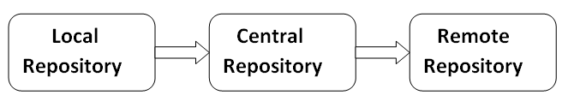
If dependency is not found in these repositories, maven stops processing and throws an error.

1) Maven Local Repository
Maven local repository is located in your local system. It is created by the maven when you run any maven command.
By default, maven local repository is %USER_HOME%/.m2 directory. For example: C:\Users\SSS IT\.m2.
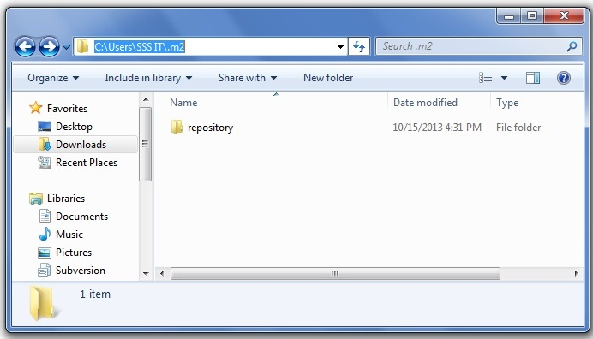

Update location of Local Repository
We can change the location of maven local repository by changing the settings.xml file. It is located in MAVEN_HOME/conf/settings.xml, for example: E:\apache-maven-3.1.1\conf\settings.xml.
Let's see the default code of settings.xml file.
settings.xml
- ...
- <settings xmlns="http://maven.apache.org/SETTINGS/1.0.0"
- xmlns:xsi="http://www.w3.org/2001/XMLSchema-instance"
- xsi:schemaLocation="http://maven.apache.org/SETTINGS/1.0.0 http://maven.apache.org/xsd/settings-1.0.0.xsd">
- <!-- localRepository
- | The path to the local repository maven will use to store artifacts.
- |
- | Default: ${user.home}/.m2/repository
- <localRepository>/path/to/local/repo</localRepository>
- -->

- ...
- </settings>
Now change the path to local repository. After changing the path of local repository, it will look like this:
settings.xml
- ...
- <settings xmlns="http://maven.apache.org/SETTINGS/1.0.0"
- xmlns:xsi="http://www.w3.org/2001/XMLSchema-instance"
- xsi:schemaLocation="http://maven.apache.org/SETTINGS/1.0.0 http://maven.apache.org/xsd/settings-1.0.0.xsd">
- <localRepository>e:/mavenlocalrepository</localRepository>

- ...
- </settings>
As you can see, now the path of local repository is e:/mavenlocalrepository.

2) Maven Central Repository
Maven central repository is located on the web. It has been created by the apache maven community itself.
The path of central repository is: http://repo1.maven.org/maven2/.
The central repository contains a lot of common libraries that can be viewed by this url http://search.maven.org/#browse.

3) Maven Remote Repository
Maven remote repository is located on the web. Most of libraries can be missing from the central repository such as JBoss library etc, so we need to define remote repository in pom.xml file.
Let's see the code to add the JBoss library in pom.xml file.
pom.xml
- <project xmlns="http://maven.apache.org/POM/4.0.0"
- xmlns:xsi="http://www.w3.org/2001/XMLSchema-instance"
- xsi:schemaLocation="http://maven.apache.org/POM/4.0.0
- http://maven.apache.org/xsd/maven-4.0.0.xsd">

- <repositories>
- <repository>
- <id>JBoss</id>
- <url>http://repository.jboss.org/nexus/content/groups/public/</url>
- </repository>
- </repositories>
- </project>

